**Instead of a job link showing the full url, can we only have the “Title and Click Here”

Make the text the same color on the email EXCEPT the links.

Emails:

Employer profile page: contact form
https://prnt.sc/26q8bgb

Hello <employer name>,

The inquiry below has been made by <name> via your profile.

Name: <name>
Email: <email>
Phone: <phone>

Message:
<message>

Kind regards,

Black Directory

Candidate profile page: contact form
https://prnt.sc/26q8bzb

Hello <candidate name>,

The inquiry below has been made by <name> via your profile.

Name: <name>
Email: <email>
Phone: <phone>

Message:
<message>

Kind regards,

Black Directory

Job details page: Contact employer
https://prnt.sc/26q8a8g

Hello <employer name>,

The inquiry below has been submitted by <candidate name> (<candidate email>) for your job "<job title>".

Subject: <subject>
Message:
<message>

Kind regards,

Black Directory

Job details page: “Email Job” button
https://prnt.sc/26q8at4

Subject: You have a Job Match

Hello <candidate name>,

<Here is a job that you may like>.

Job Link: <job title>

Kind regards,

Black Directory

If a candidate applies for a job, an email will be sent to both employer and candidate

To candidate: https://prnt.sc/26q8cgd

Hi <candidate name>,

This is to confirm your job application for '<job title>' has been submitted to <employer name>.

Best wishes,

Black Directory

To employer: https://prnt.sc/26q8d39

Hi <employer name>,

You have received a new application from "<candidate name>" for your job "<job title>".
"<candidate name>"’s profile, application and CV can be found your Account or you can find the CV attached within.

Best wishes,

Black Directory

Apply by email job, send the application email to both employer and candidate
To candidate: https://prnt.sc/26q8euw

Hello <candidate name>,

This is to confirm your job application for '<job title>' has been submitted to <employer name>.

Best wishes,

Black Directory

To employer: https://prnt.sc/26q8el2

Hi <employer name>,

You have received a new application for your job "<job title>".

First Name: <first name>
Last Name: <last name>
Email: <email>
Phone: <phone>

Message: <message>

Kind regards,

Black Directory

Send email to candidate about the new jobs posted by the following employers
https://prnt.sc/26q8f7g

Dear <candidate name>,

A new job "<job title>" has been posted by "<employer name>" who you are following.

Best regards,

Black Directory

Job expiry
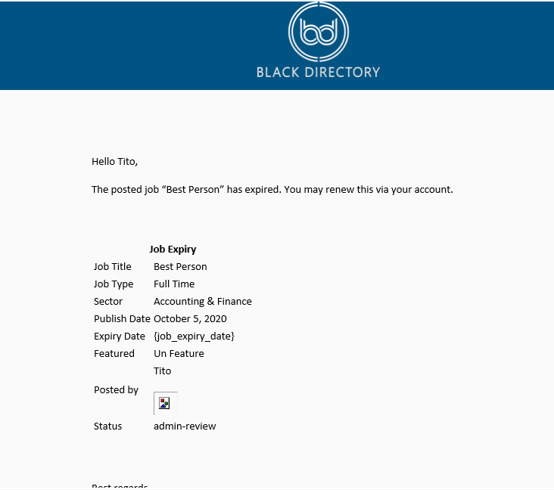

Subject: Black Directory – Job Expiry

Dear <employer name>,
The posted job “<job title>” has expired. You may renew this via your account.

Job Expiry
Job Title | <job_title>
Job Type | <job_type>
Industry | <industry>
Post Date | <post_date>
Expiry Date | {apply_before_date}

Best regards,

Black Directory

Job update
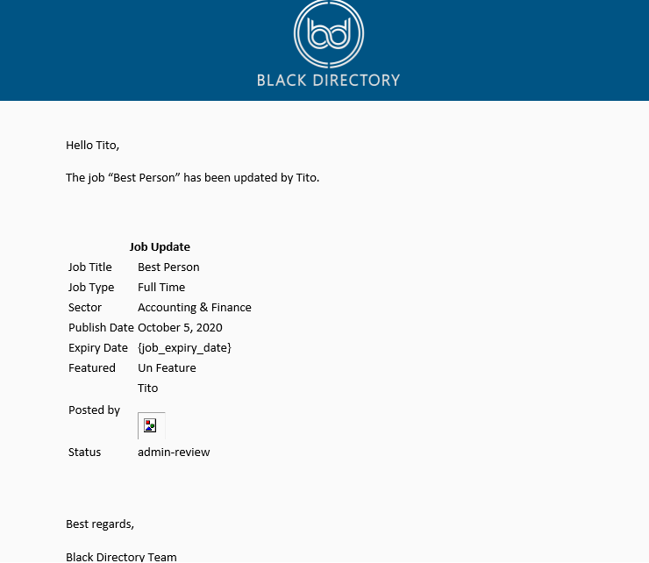
Subject: Black Directory – Job Update

Dear <employer_name>,

The posted job “<job title>” has been updated.

Job Update
Job Title | <job_title>
Job Type | <job_type>
Industry | <industry>
Post Date | <post_date>
Expiry Date | {apply_before_date}

Best regards,

Black Directory

Email from Advertise with us page
https://prnt.sc/26q88sp

From: <name>
Email: <email>
Subject: <subject>

<message>

Email from Contact Us page
https://prnt.sc/26q87bj

From: <name>
Email: <email>
Subject: <subject>

<message>

Welcome email after registration
https://prnt.sc/26q85jr

Hi <user name>,

Thank you for registering with Black Directory. We look forward to you using our platform and enjoying all the features we have to offer.

Kind regards,

Black Directory

Verification email after registration

***CAN YOU EMBED LINK in click here.
https://prnt.sc/26q851n

Hello <user name>,

Please confirm your email address to complete your account registration. Please <click here>.

Kind regards,

Black Directory

Email to Admin and vendor on new withdraw request
To admin: https://prnt.sc/26q8fum

Dear BD Payments,

<vendor name> has submitted a withdrawal request of £<amount>.

Kind regards,

<vendor name>

To vendor: https://prnt.sc/26q8gb1

Subject: Black Directory – Withdraw Request

Dear <vendor name>,

This is to confirm that we have received your withdrawal request of amount £<amount> from your account. Your request is now being processed.

Kind regards,

Black Directory Payments

Email to vendor on withdraw request status change
https://prnt.sc/26q8glw

Dear <vendor name>,

Your withdraw request of amount £<amount> has been successfully processed. The funds have now been transferred and should be in to your designated bank account in 3-5 working days.

Thank you for using Black Directory.

Best regards,

Black Directory Payments

Send email to Admin when a listing is claimed

Dear Black Directory,

A user has claimed one of the directory listings.

Listing: <listing.title>
First Name: <firstname>
Last Name: <lastname>
Phone: <phone>
Email: <email>

Send notification email when forum reply is submitted

Dear <user name>,

A user has replied to a forum topic you are following.

Forum: <forum link>
Topic: <topic link>

Content
<reply content>

Kind regards,

Black Directory

Email to vendor on new order

https://prnt.sc/6e86X-Vo8oNQ

Subject: <You have a new order> #<order number>

Dear <vendor name>,

You have received a new order of the following items.

Order #<order number>
<order summary table>

Best regards,

Black Directory

Email to customer on order status change

Dear <customer name>,

Your order status has been updated.

Order: <order id>
Status: <updated status>

Best regards,

Black Directory

Password reset
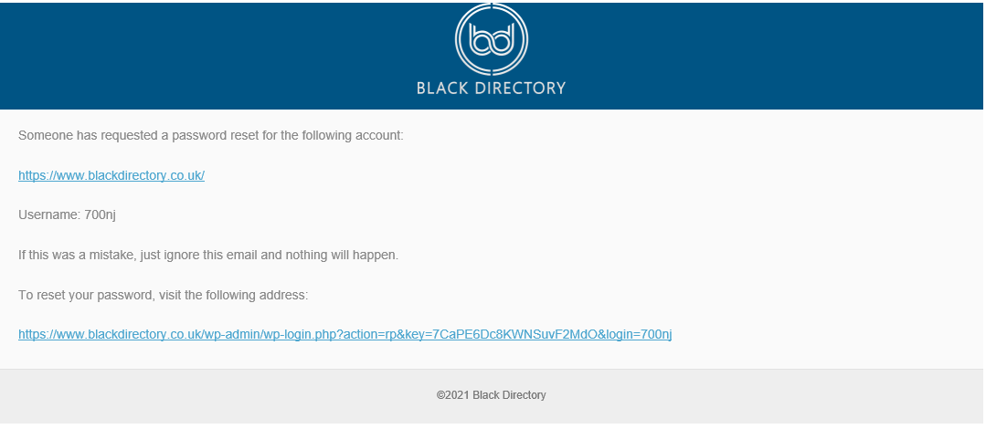

Subject: Black Directory – Password Reset

Hello,
Someone has requested a password reset for the following account:
https://www.blackdirectory.co.uk/
Username: <user name>
If this was a mistake, just ignore this email and nothing will happen.
To reset your password, visit the following address:

Black Directory – Event Confirmation
**TEXT SHOULD BE SAME SIZE**
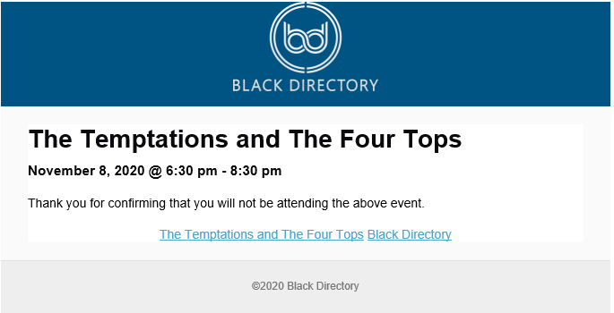
Subject: Black Directory – Event Confirmation

Hello <user_name>,

<event>
<event_date> @ <event_time>

Thank you for confirming that you will <event_status> the above event.

Best regards,

Black Directory Team

Email to admin when user requests for deactivate or delete his account

Dear Black Directory,

A user has requested to <deactivate/delete> his/her account.

User Email: <user_email>
Request: <request_type>

Description: <description>

Email to User when user requests for deactivate or delete his account

Dear <user name>,

You have requested to <deactivate/delete> your account for the following account:

User Email: <user_email>
Your requested in now being processed.

Thank you for your patience.

Kind regards,

Black Directory

